Spatial Data Querying and Mining Demo – User Interface

# Modules

1. User Profiling.
2. Diversified Region Query.
3. POI Recommendation.
4. POI Searching.
5. Aspect-in-region Query.
6. Additional: POI Subscription.

# Framework

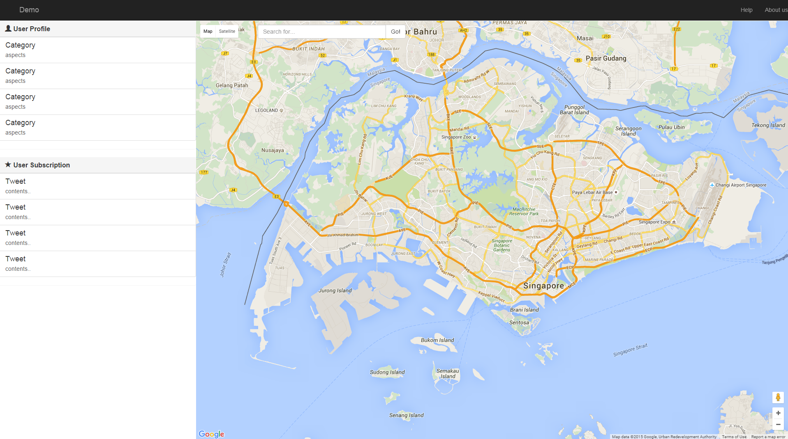

# User Profiling

* Input:
  + user login.
* Output:
  + User category / aspect interests.
    - Show 3 categories of user interests on user profile panel.
    - Show 3 aspects of each interested category.
  + User personal regions.
    - Show 3 user’s personal regions (Gaussian distribution) on the map.
* Example:

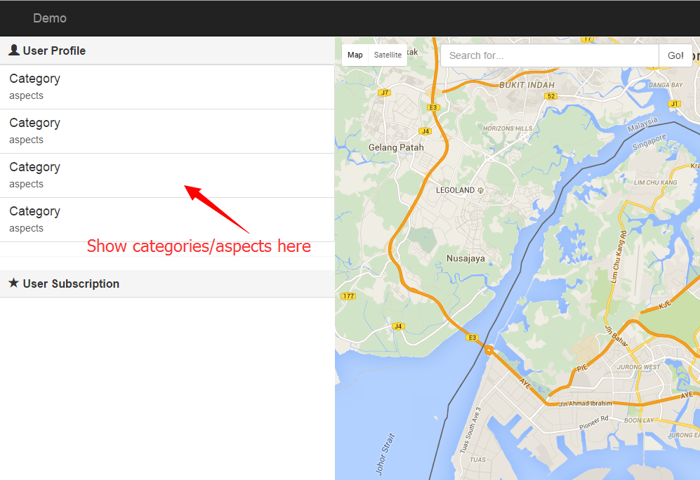 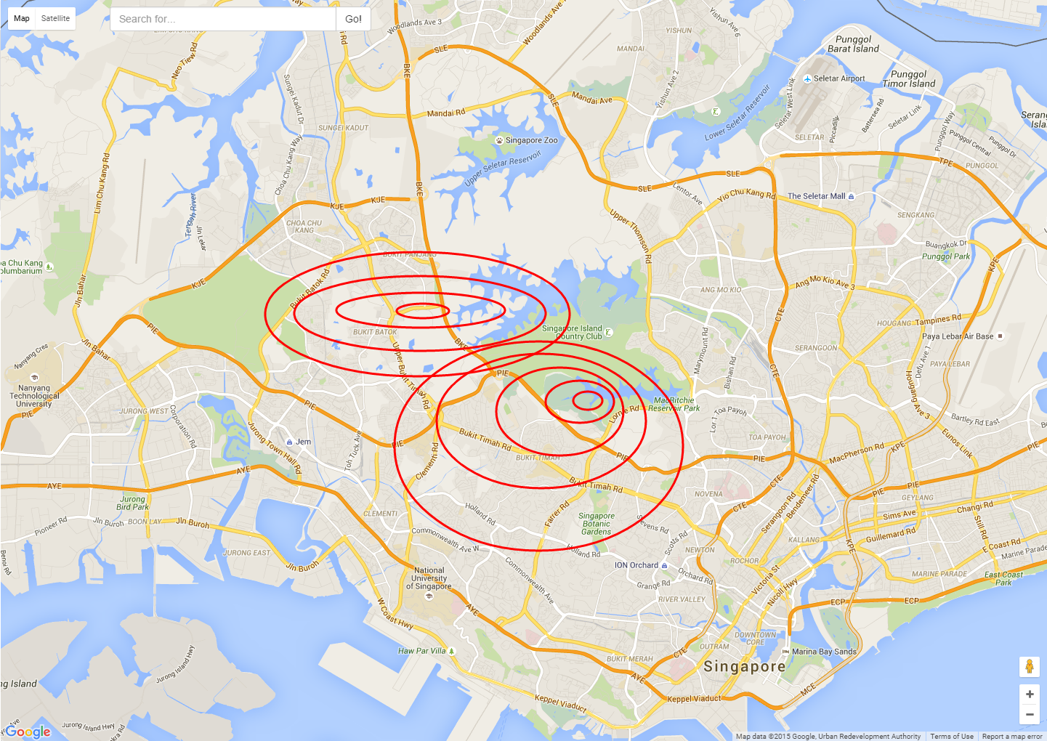

# Diversified Region Query

* Input:
  + Category.
  + Region size.
* Output:
  + Show a rectangular region, which is the most diversified region of the given category.
  + Show POIs of given category in this region as http://maplacejs.com/images/red-dot.png.
* Example:

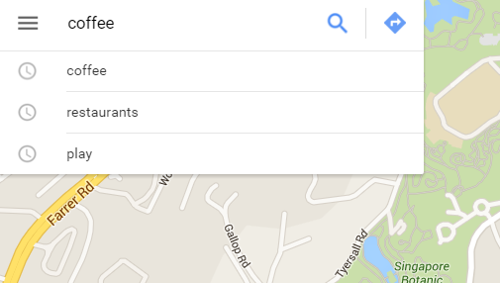 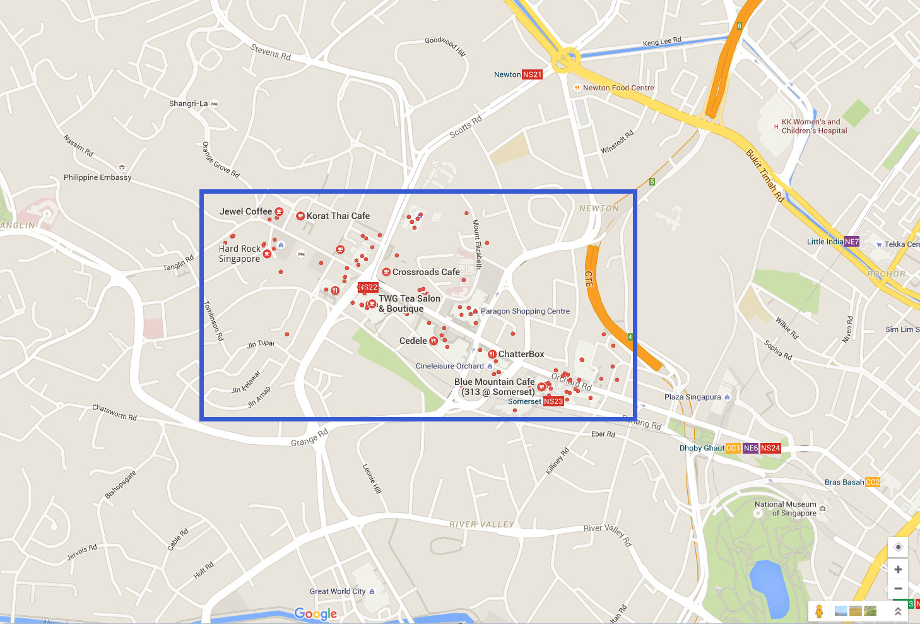

# POI Recommendation

* Input:
  + Some key words.
* Output:
  + Show top-k recommended POI in the recommendation list.
  + Show corresponding POI on the map as http://maplacejs.com/images/red-dot.png.
* Example:

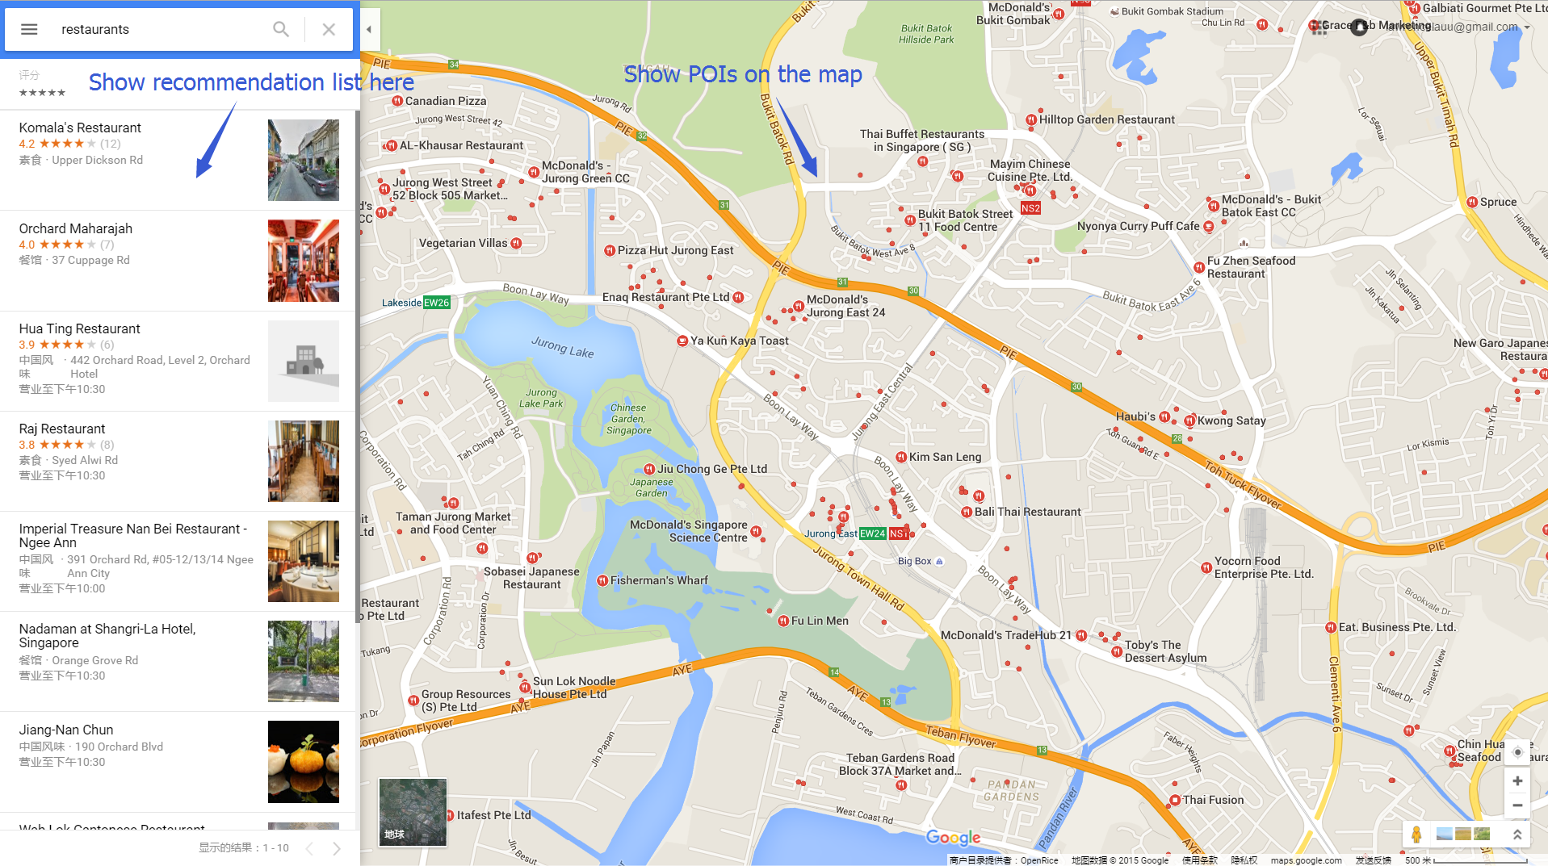

# POI Searching

* Input:
  + Choose a location on map.
  + Some key words.
* Output:
  + Show related POI near the given location, on the map as http://maplacejs.com/images/red-dot.png.
* Example:

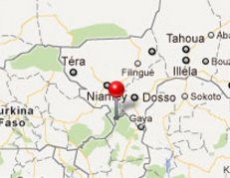 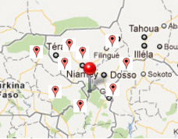

# Aspect-in-region Query

* Input:
  + Category.
  + Select a rectangular area on the map.
* Output:
  + Show the top 3 most positive/negative aspects in the region of the specified category.
* Example:

 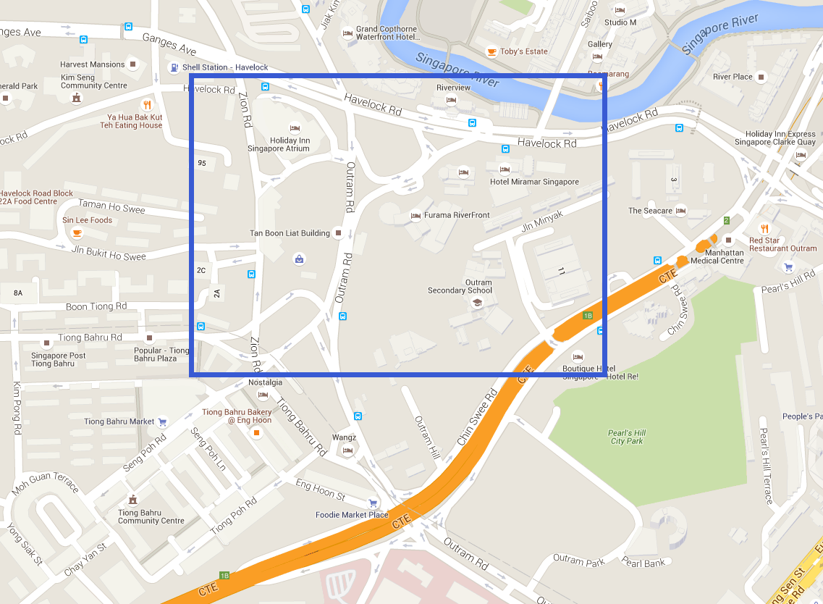

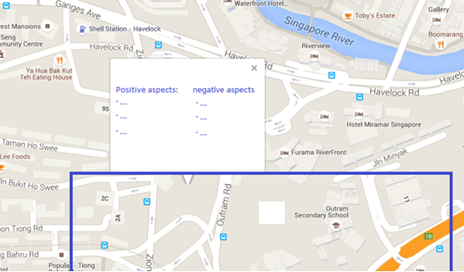

# Additional Function: POI subscription

* Input:
  + Choose POI on map and click subscribe.
* Output:
  + Show tweets in the subscription list.
* Example:

